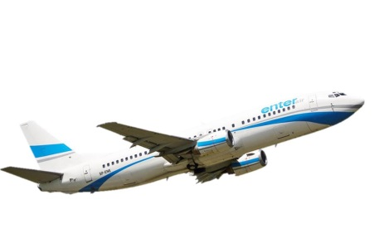
enterair
Dear Pilot, please fill in the questionnaire

Name and Surname
Nationality
Country issuing the passport
Country of residence
License number
Total flight time
Medical certificate validity date (dd/mm/yyyy)
ICAO English level
Do you hold B737 Type Rating? (Yes/No)
Total flight time on B737 (if applicable)
If you hold B737 Type Rating, please specify the type(s) (CL, NG, both)
Are you interested in doing Type Rating + Line Training 500 BH (Yes/No)
OR
Are you interested in doing Line Training (500 BH)? (Yes/No)

